Basic Geometry Practice

# 20 Minutes – (Don’t skip any questions)

1. Quantitative Comparison:

In the diagram, AC = 6. CE = 12, DF = 4, and AB is parallel to DE.

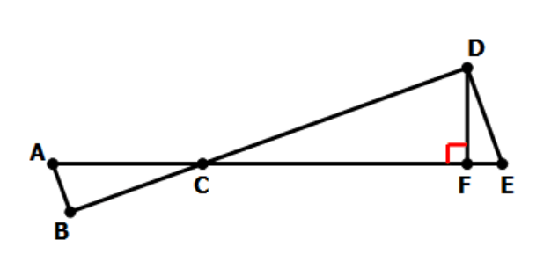

|  |  |
| --- | --- |
| Quantity A | Quantity B |
| The area of triangle ABC | 12 |

|  |  |  |  |
| --- | --- | --- | --- |
| 1. A > B | 1. B > A | 1. A = B | 1. Can’t be determined |

1. Quantitative Comparison:

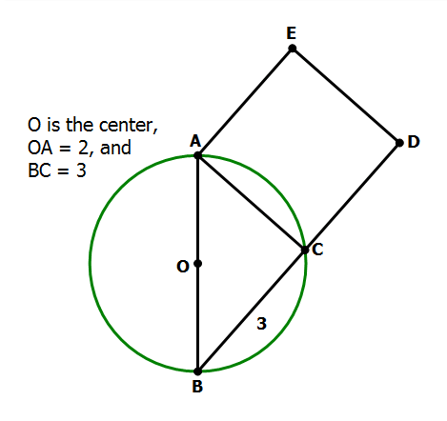

|  |  |
| --- | --- |
| Quantity A | Quantity B |
| The area of square ACDE | 12 |

|  |  |  |  |
| --- | --- | --- | --- |
| 1. A > B | 1. B > A | 1. A = B | 1. Can’t be determined |

1. Quantitative Comparison:

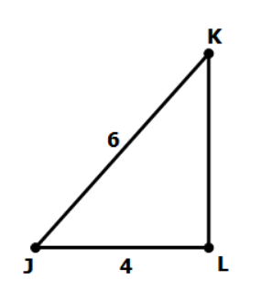

|  |  |
| --- | --- |
| Quantity A | Quantity B |
| The area of triangle JKL | 11 |

|  |  |  |  |
| --- | --- | --- | --- |
| 1. A > B | 1. B > A | 1. A = B | 1. Can’t be determined |

1. Quantitative Comparison:

In the diagram, O is the center of the circle, and AB is a diameter.

Region J is the area between chord AC and the arc of the circle.

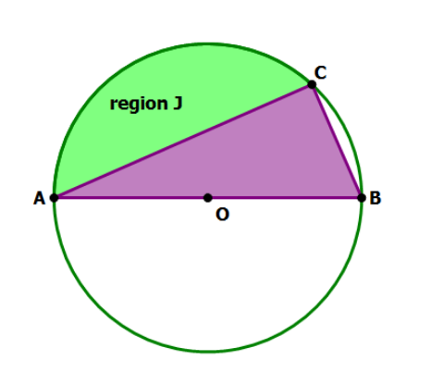

|  |  |
| --- | --- |
| Quantity A | Quantity B |
| Area of triangle ABC | Area of region J |

|  |  |  |  |
| --- | --- | --- | --- |
| 1. A > B | 1. B > A | 1. A = B | 1. Can’t be determined |

1. Quantitative Comparison:

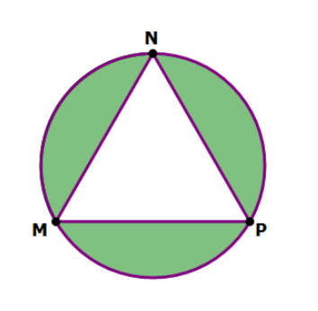

|  |  |
| --- | --- |
| Quantity A | Quantity B |
| Area of triangle MNP | Area of the shaded region |

|  |  |  |  |
| --- | --- | --- | --- |
| 1. A > B | 1. B > A | 1. A = B | 1. Can’t be determined |

1. Quantitative Comparison:

In the diagram, JKLM is a square.

Point S is the midpoint of KL, and point T is the center of the square.

Point O is on segment ST, and is the center of the circle, which passes through both K and L.

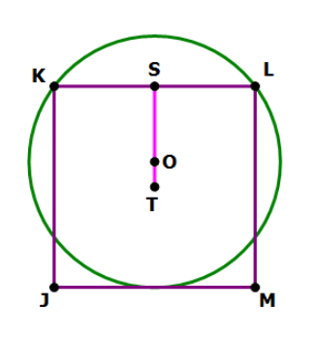

|  |  |
| --- | --- |
| Quantity A | Quantity B |
| Area of circle O | Area of square JKLM |

|  |  |  |  |
| --- | --- | --- | --- |
| 1. A > B | 1. B > A | 1. A = B | 1. Can’t be determined |

1. Quantitative Comparison:

In the diagram, $\frac{AB}{AC}=\frac{AC}{BC}$

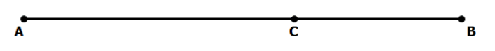

|  |  |
| --- | --- |
| Quantity A | Quantity B |
|  |  |

|  |  |  |  |
| --- | --- | --- | --- |
| 1. A > B | 1. B > A | 1. A = B | 1. Can’t be determined |

1. In the figure below, a square is inscribed in a circle and another circle is inscribed in the square. If the area of the smaller circle is $π$, what is the area of the larger circle?

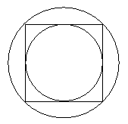

|  |  |  |  |  |
| --- | --- | --- | --- | --- |
| $π\sqrt{2}$ | $π\sqrt{3}$ | $2π$ | $3π$ | $4π$ |

1. Rectangle R has length 30 and width 10, and the square S has length 5. The perimeter of S is what fraction of the perimeter of R? (Numeric Entry)

|  |  |
| --- | --- |
| |  | | --- | |  | |
| |  | | --- | |  | |

1. Quantitative Comparison:

Three circles with centers online segment PQ are tangent at points P, R and Q,

where point R lies on line segment PQ.

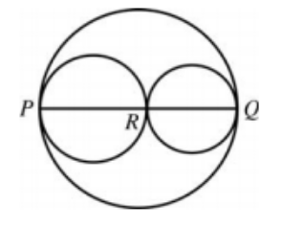

|  |  |
| --- | --- |
| Quantity A | Quantity B |
| The circumference of the largest circle. | The sum of the circumference of the two smaller circles. |

|  |  |  |  |
| --- | --- | --- | --- |
| 1. A > B | 1. B > A | 1. A = B | 1. Can’t be determined |

1. In a triangle ABC, the measure of the angle B is $90°$, the length of side AB is $4$, and the length of side BC is $x$. If the length of hypotenuse AC is between $4$ and $8$, which of the following could be the value of $x$? Indicate all such values.

|  |  |  |  |  |  |
| --- | --- | --- | --- | --- | --- |
| $1$ | $2$ | $3$ | $4$ | $5$ | $6$ |

1. The floor space of a certain market is rented for $15 per 30 square feet per one day. In the market, Alice rented a rectangular floor space that measured 8 feet by 15 feet, and betty rented a rectangular floor space that measured 15 feet by 20 feet. If each woman rented her floor space for one day, how much more did Betty pay more than Alice?

|  |  |  |  |  |
| --- | --- | --- | --- | --- |
| $\$27$ | $\$36$ | $\$54$ | $\$90$ | $\$180$ |